SWC2333 :OBJECT ORIENTED PROGRAMMING

LAB SESSION 1: INTRODUCTION TO OBJECT-ORIENTED PROGRAMMING

# Get started!

[Bluej Logo](https://www.google.com/url?sa=i&url=https%3A%2F%2Fwww.logolynx.com%2Ftopic%2Fbluej&psig=AOvVaw0SyzevThJ804gfqwx8D2MP&ust=1606051169998000&source=images&cd=vfe&ved=0CNIBEK-JA2oXChMIyIGCi92T7QIVAAAAAB0AAAAAEAI)s [:logolynx.com](https://www.google.com/url?sa=i&url=https%3A%2F%2Fwww.logolynx.com%2Ftopic%2Fbluej&psig=AOvVaw0SyzevThJ804gfqwx8D2MP&ust=1606051169998000&source=images&cd=vfe&ved=0CNIBEK-JA2oXChMIyIGCi92T7QIVAAAAAB0AAAAAEAI)



# CREATE A JAVA PROJECT

1. Open **BlueJ** Program from Start Menu.
2. Create a new Project. Click **Project > New Project**. Name your project as **SWC2333**. Then click the create button.
3. Click New Class button to create a new program.
4. A dialog box will appear, type your Class Name and choose Class for your Class Type. Then, click the OK button.
5. Double click on the class file, select all and delete all. (Press Ctrl A + DELETE key).
6. Start writing your program. what is your project name?

# EXERCISE 1: This is a simple Java program that DISPLAYS messages at the CONSOLE window

1. Open your project, and create a new class named **MyPROG1.**
2. Double click on the **MyPROG1** file, select all and delete all. (Ctrl A and press delete key).
3. Type the following code.

//This is my First Java Program

public class MyProgram1

{

public static void main(String[]args)

{

System.out.println("Hello World!!");

System.out.println("My First JAVA Programming.");

}

}

1. Compile and execute (run) the program.
2. Try to change the message to your own message, or add extra lines.
3. Your lecturer will explain the detail about the program.

# EXERCISE 2: This is a simple Java program that DISPLAYS messages using JOptionPane

1. Create a new class, you can give any name. for example : **MyPROG2**
2. Type the following code.

/*

This program display using JOptionPane

*/

import javax.swing.JOptionPane;

public class MyProgram2

{

public static void main(String[]args)

{

JOptionPane.showMessageDialog(null,"Hello World!! ");

JOptionPane.showMessageDialog(null, "My First JAVA Programming.", "JAVA" , JOptionPane.INFORMATION_MESSAGE);

System.exit(0);

}

}

1. Compile and execute (run) the program.
2. Try to change the message, **title or the icon on the dialog box**.
3. Your lecturer will explain the detail about the program.

# EXERCISE 3 : using print() and println()

1. Create a new class named **Lines**. Compile and run.

//This is another simple Java Program public class Lines

{

public static void main(String args [])

{

System.out.println("Programming is great fun!"); //using println System.out.print ("JAVA is great "); //using print

System.out.println ("and I Love JAVA!");

}

}

bbbbbbbbbbbbbbbbbbbbbbbbbbbbbbbbbbbbbbbbbbbbbbbbbbbbbbbbbbbbbbbbbbbbbbbbbbbbbbbbbbbbbbbbbbbbbbbbbbbbbbbbbbbbbbb

EXERCISE 1 :

/**

*Program description: To displays messages at the console window

*

*Author: Muhammad Aizat

*Date: 29th May 2024

*/

//This is my First Java Program

public class MyProgram1

{

public static void main (String[]args)

{

System.out.println("Hello World!!");

System.out.println("My Name Is Aizat.");

System.out.println("I Just Learn How To Use The BlueJ.");

System.out.println("This Is My First JAVA Programing.");

}

}

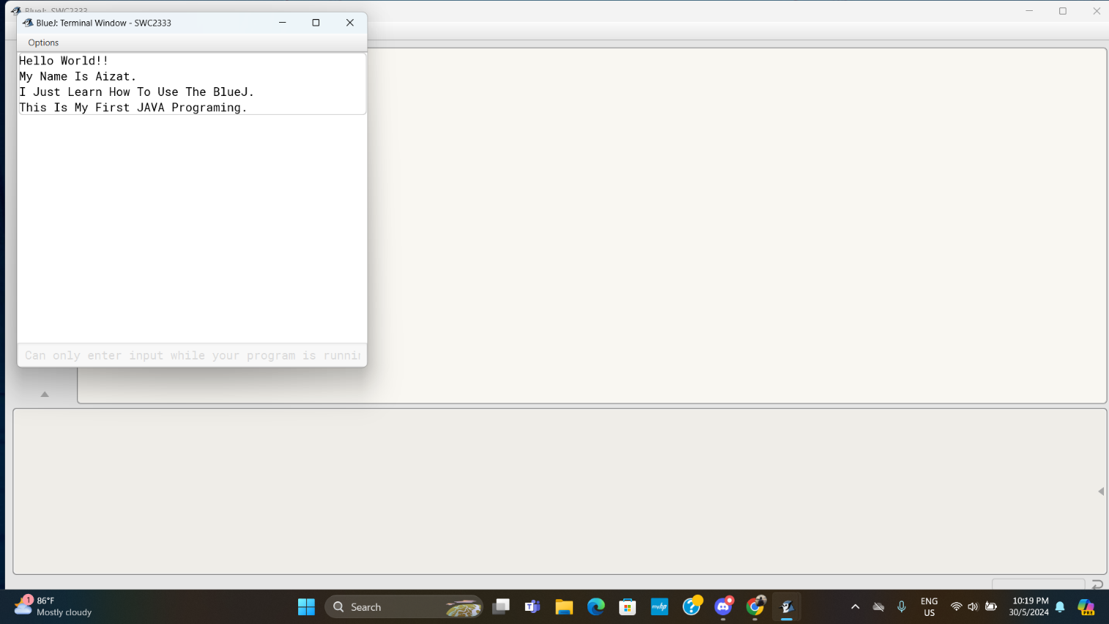

EXERCISE 2:

/**

*Program description: To displays messages using JOptionPane

*

*Author: Muhammad Aizat

*Date: 29th May 2024

*/

import javax.swing.JOptionPane;

public class MyProgram2

{

public static void main (String[]args)

{

JOptionPane.showMessageDialog(null,"Hello World!!",null,1);

JOptionPane.showMessageDialog(null,"My First JAVA Programming.","JAVA",1);

JOptionPane.showMessageDialog(null,"My Name Is Aizat.","My Information",1);

System.exit(0);

}

}

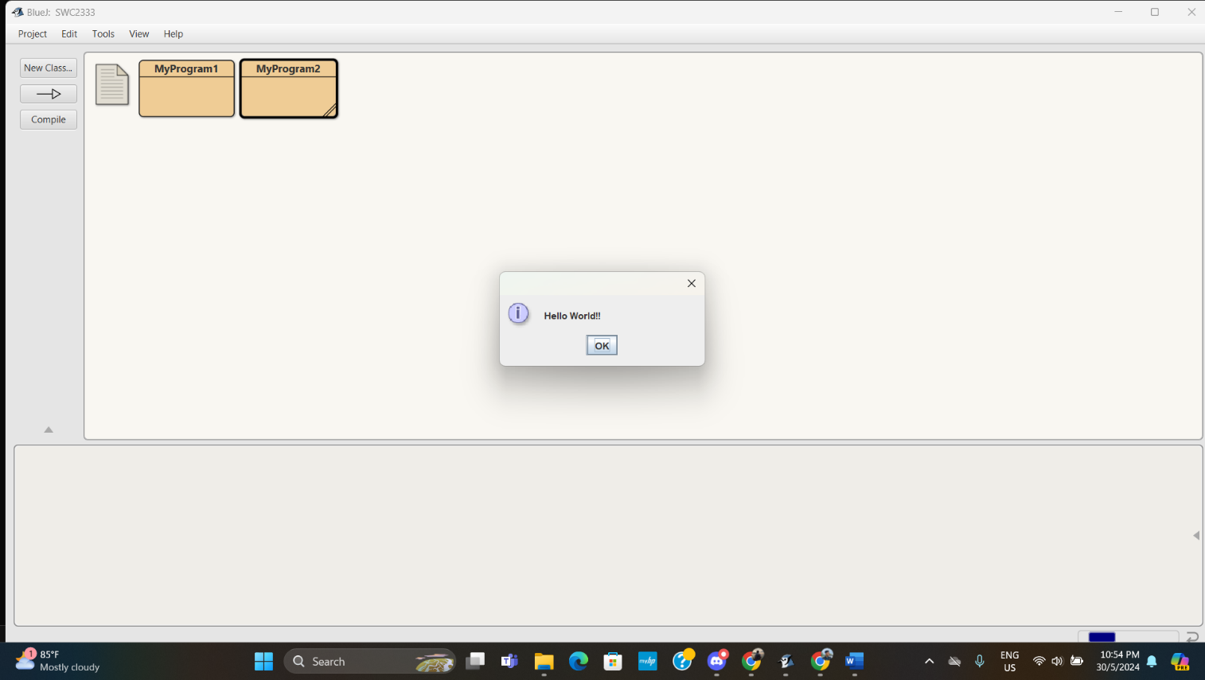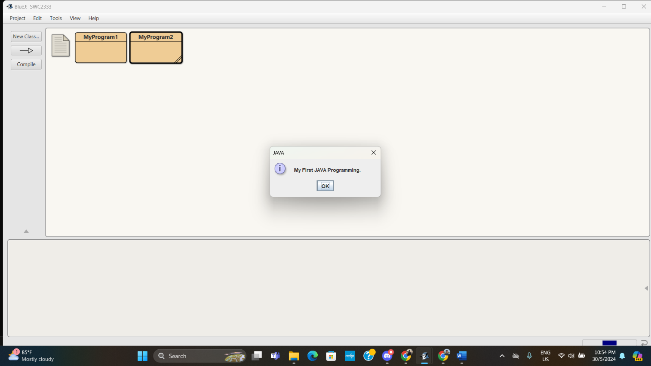

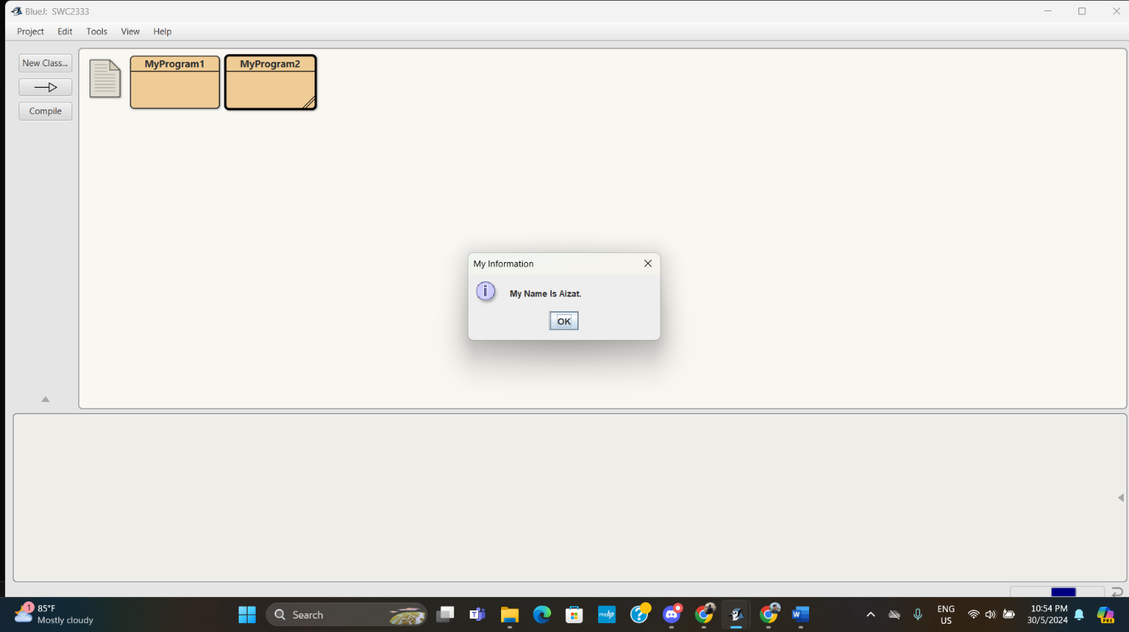

EXERCISE 3:

/**

*Program description: Using print() and println()

*

*Author: Muhammad Aizat

*Date: 29th May 2024

*/

//This is another simple Java Program

public class Lines

{

public static void main(String[]args)

{

System.out.println("Programming is great fun!"); //using println

System.out.print("JAVA is great!"); //using print

System.out.println("and I Love JAVA!");

}

}

